

|  |  |
| --- | --- |
| **Challenge #1**  **Marine acoustic sensing using repurposed fibre optic cables** |  |

**Context**

We invite you to work with an exciting new technology; distributed fibre optic sensing. This amazing sensing system uses off the shelf fibre optic cables, like the ones we use for our internet and telecoms, and repurposes them to be vast arrays of microphones (or thermometers) measuring vibrations (and temperatures) every couple of meters over 10’s of kilometres.

We have access to the Ocean Observatories Initiative RAPID dataset where two seafloor cables located offshore Oregon recorded data over a 4 day period in 2021 (Wilcock et al., 2023). Over that time period we can observe wave and tidal effects, earthquakes, marine mammals (blue & fin whales), shipping and road traffic. The challenge is to integrate multiple datasets, separate the signals from the noise and improve detection and classification on these data.

In this hackathon, you will be provided with access to these seafloor cable data, and your task will be to develop algorithms that can process and analyze these phenomena.

Example:

|  |  |  |
| --- | --- | --- |
| Blue whale vocalizations | | |
| Propeller Noise | Earthquake | Data examples from Wilcock et al., 2023 (top, left) and OptaSense. |

**Challenge Goals**

This is a multi-faceted dataset that includes fibre optic Distributed Temperature Sensing (DTS), fibre optic Distributed Acoustic Sensing (DAS), AIS (vessel tracking data), bathymetry, earthquake catalogues and weather data. For this reason there are many different possibilities, we have suggested a few challenges below. You could tackle these sequentially or you could focus on just one. You are welcome to propose your own challenge as there are so many possibilities!

**Challenge 1: Signal Conditioning**

Whilst fibre optic data provides new acoustic sensing opportunities it does has challenges including a lower sensitivity. The first challenge is to improve the signal conditioning to improve data quality. In other words,

* What is the optimal processing flow for vessel noise, marine mammals, waves and earthquakes?
* These are vast datasets (26 Terabytes) so automated fast processing automated detection are needed.

How many vessels, whales and earthquakes can your team find !

**Challenge 2: Information Extraction**

Detecting and classifying an event is just the start of an information extraction process. Once we have identified a signal we want to extract more information. So, in the case of propeller noise we would want to know how fast the propeller is turning, how many blades does it have and where is the vessel? For marine mammals we might want to identify the species, it location and its depth. This challenge is to take the identified signals and try to extract as much information from it, such as

* Locating & Tracking vessels/marine mammals
* Characterize ocean hydrodynamics tides/waves etc.

**Challenge 3: Visualization of integrated datasets**

This is a diverse dataset that would benefit from interactive data visualization tools. If you want to be inspired then take a look at the recent ‘Big Glass Mic’ exhibit at the Victoria & Albert Museum exhibit [[link](https://www.vam.ac.uk/bigglassmic/), Stamen Design]. This shows an interactive acoustic data visualization from ‘dark fibre’ around Stanford University’s campus using waterfall plots and spatial visualizations of the fibre.

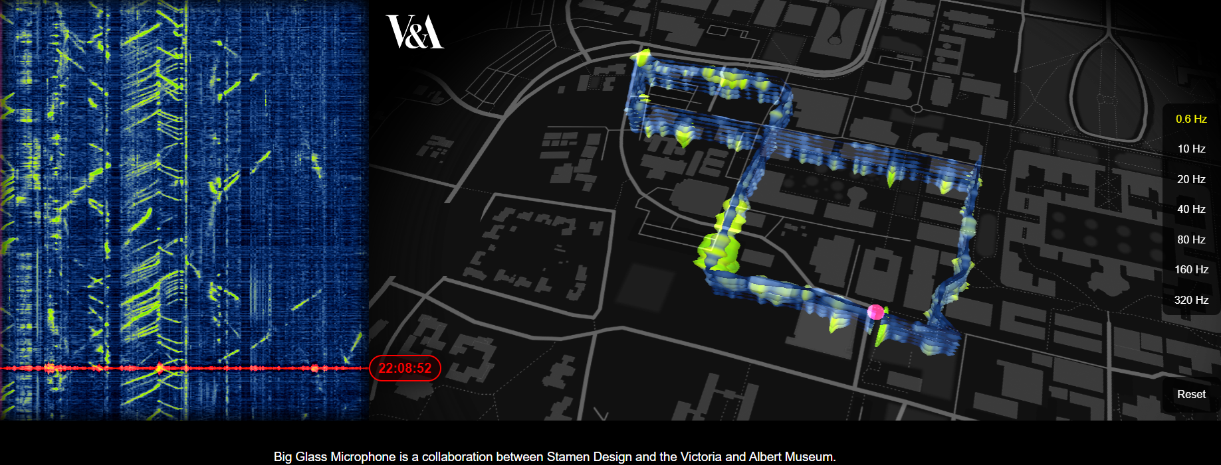

**Pre-requisites**

We will provide a curated data subset and Jupyter notebooks to jumpstart the process. We will also suggest some libraries that you may wish to preinstall and test.

You will need to bring a laptop with appropriate computing tools e.g. Python / MATLAB etc., as well as any relevant libraries/toolboxes e.g. NumPy, Matplotlib, PyTorch, TensorFlow.

**Background Material**

1. RAPID: Distributed Acoustic Sensing on the OOI’s Regional Cabled Array – Ocean Observatories Initiative. [[Link](https://oceanobservatories.org/pi-instrument/rapid-a-community-test-of-distributed-acoustic-sensing-on-the-ocean-observatories-initiative-regional-cabled-array/)]
2. Victoria & Albert Museum Big Glass Mic Data Visualization [[Link](https://www.vam.ac.uk/bigglassmic/)]
3. Distributed acoustic sensing recordings of low-frequency whale calls and ship noise offshore Central Oregon: JASA Express Letters: Vol 3, No 2 (scitation.org) [[pdf](https://asa.scitation.org/doi/10.1121/10.0017104)]

**Online Resources**

awesome-das: A curated list of DAS tools and resources on Github. [[Link](https://github.com/DAS-RCN/awesome-das)]

DAS4Whale <https://github.com/leabouffaut/DAS4Whales>

DASDae [DASDAE · GitHub](https://github.com/DASDAE/)

Ocean Observatories Initiative RAPID dataset

Wikipedia: Distributed Acoustic Sensing [[link](https://en.wikipedia.org/wiki/Distributed_acoustic_sensing)]

Segment Anything Model [[link](https://www.linkedin.com/pulse/segment-anything-model-sam-detecting-earthquakes-das-joses-williams?utm_source=share&utm_medium=member_android&utm_campaign=share_via)]

Oriented Filtering [[link](https://github.com/aaspip/pyseistr/blob/main/demos/test_pyseistr_das.py)]

**Videos**

Using DAS to observe nearshore waves and processes - Hannah Glover & Marcela Ifju [[link](https://youtu.be/vHcL6WljtQk)]

Seafloor Fibre Optic Sensing Joint IRIS & DAS RCN Webinar [[link](https://www.youtube.com/watch?v=BS4dtG-12Q4)]

**References**

Wilcock, W. and Ocean Observatories Initiative (2023). Rapid: A Community Test of Distributed Acoustic Sensing on the Ocean Observatories Initiative Regional Cabled Array [Data set]. Ocean Observatories Initiative. <https://doi.org/10.58046/5J60-FJ89>

Lior, I., A. Sladen, D. Rivet, J.-P. Ampuero, Y. Hello, C. Becerril, H. Martins, P. Lamare, C. Jestin, S. Tsagkli, C. Markou. 2021. On the Detection Capabilities of Underwater Distributed Acoustic Sensing. JGR 126 (3).

Bouffaut, L, et al, (2022) Eavesdropping at the speed of light: distributed acoustic sensing of Baleen whales in the arctic. *Frontiers in Marine Science,* 9. [doi.org/10.3389/fmars.2022.901348](https://doi.org/10.3389/fmars.2022.901348)

Waagaard, OH, et al, (2021) Real-time low noise distributed acoustic sensing in 171 km low loss fiber. *OSA Continuum,* 4(2), 688–701. [doi.org/10.1364/OSAC.408761](https://doi.org/10.1364/OSAC.408761)

Waagard, O. H. 2022. Listening across the oceans: Distributed acoustic sensing.

Ugalde, A. 2022. Noise levels and signals observed on submarine fibers in 1 the Canary Islands using DAS.

Taweesintananon, K. 2023. Distributed acoustic sensing of ocean-bottom seismo-acoustics and distant storms: A case study from Svalbard, Norway. Geophysics.

María R. Fernández-Ruiz, M. 2022. Seismic Monitoring With Distributed Acoustic Sensing From the Near-Surface to the Deep Oceans. Journal of Lightwave Technology 40 (5) 1453.

Rørstadbotnen RA, Eidsvik J, Bouffaut L,Landrø M, Potter J, Taweesintananon K, Johansen S, Storevik F, Jacobsen J,Schjelderup O, Wienecke S, Johansen TA,Ruud BO, Wuestefeld A and Oye V. 2023. Simultaneous tracking of multiple whales using two fiber-optic cables in the Arctic. Front. Mar. Sci. 10:1130898.doi: 10.3389/fmars.2023.1130898

Andreia Pereira, Danielle Harris, Peter Tyack, and Luis Matias. 2016. Lloyd’s mirror effect in fin whale calls and its use to infer the depth of vocalizing animals. Proc. Mtgs. Acoust. 27, 070002; doi: 10.1121/2.0000249

Hiroyuki Matsumoto, Eiichiro Araki, Toshinori Kimura, Gou Fujie, Kazuya Shiraishi,

Takashi Tonegawa, Koichiro Obana, Ryuta Arai, Yuka Kaiho, Yasuyuki Nakamura,

Takashi Yokobiki, Shuichi. 2021. Detection of hydroacoustic signals on a fiber‑optic submarine cable. Nature Scientific Reports. 11:2797

M. Karrenbach1*, R. Ellwood1, V. Yartsev1, E. Araki2, T. Kimura2, H. Matsumoto2. 2020. Long-range DAS Data Acquisition on a Submarine Fiber-optic Cable. EAGE Workshop on Fiber Optic Sensing for Energy Applications in Asia Pacific.

## Data Organization

The data from the North and South cables have been acquired by two separate companies; OptaSense and Silixa. OptaSense recorded data on both cables at different times with different recording parameters and used the HDF5 data format. Silixa recorded data on the South cable with the same recording parameters in the TDMS format.

For your convenience we have converted some of the data into the MatLab™ data format with a format naming convention of

Company_Cable_YYYYMMDDHHMMSS_GL_SPACING_SAMPLINGFREQUENCY.mat

where

Company = Company name (Either OPT for OptaSense or SLX for Silixa)

Cable = Cable name (either North or South)

YYYYMMDDHHMMSS = UTC Date and Time stamp

GL = Gauge Length in meters (related to fibre optic DAS)

SPACING = Spacing between adjacent channels in the data

SAMPLINGFREQUENCY = Sampling frequency in Hertz

So for example



is data recorded by OptaSense on the North cable on the 4th November 2021 at 02:02:51 UTC using a gauge length of 51m, with a 2m channel spacing at 200Hz.

The data examples are stored in the data folder with sub folders

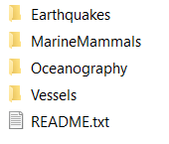

Data can be converted from the original HDF5 and TDMS data formats using the Python Jupyter notebook

UKAN2023_ConvertToMatlabFormat_v01.ipynb

## Code

We provide Python Jupyter notebooks (and MatLab™ scripts) to provide a quick start to the challenges;

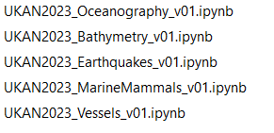

These notebooks will read in data examples, implement minimal processing and display data plots.



We have converted some code from Python to Matlab™.

### Marine Mammals

The data were acquired in a region where fin and blue whales are present. A fin whales typical call lasts for about 1 s around 20 Hz. Blue whale calls appear in the 15-40 Hz range.

|  |  |
| --- | --- |
| The plot to the right shows an example of multiple fin whales from the 2nd November 2021 around 07:36.  These calls take on a chevron shape where the apex (around channel 1700) corresponds to the closest channel to the fin whale. The slopes of the chevron can be used to infer the distance from the cable (linear slopes indicate the whale is close to the cable; curved slopes indicate the whale is more distance).  Propeller noise from a shipping vessel (MMSI 538007681) can also be observed around channel 1500.  The data shown is after application of a band pass frequency filter centred around 20 Hz. |  |

### Vessels

Using AIS (Automatic Identification System is a messaging service describing the passage of marine vessels) data we can see that multiple vessels pass above the two cables during the 4 day recording period. The AIS data have been downloaded and stored as a CSV file;

ClosestVessels.csv

The AIS information is summarized in the timeline below where the horizontal axis indicates the date and time, the three horizontal lines indicate the data coverage recorded on the North cable by OptaSense (black line) and the cyan and blue cables indicate data recorded on the South cable by OptaSense (cyan) and Silixa (blue). The red lines indicate the approximate times at which vessels pass over the two cables. The vertical text indicates the MMSI number (Marine Mobile Service Identity is a unique number used to identify a marine vessel) for the vessel.

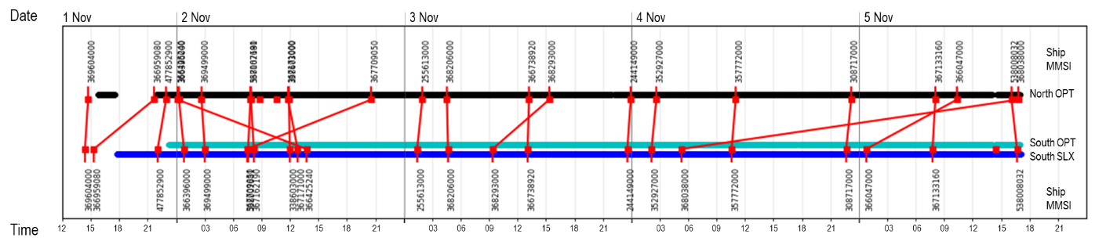

As an example we can see that that the vessel with an MMSI number of 357772000 passes over the South cable at approximately 11 am on the 4th November for which data is available from the OptaSense and Silixa. The same vessel passes over the North cable at a slightly later time for which OptaSense data is available.

Another way to look at the AIS data is to plot the geographic information relative to the cables.

|  |  |
| --- | --- |
| Tracks for individual vessels passing close to the cables on the 1st November 2021 is shown to the right. The location of the North and South cables is shown as blue lines.  Where AIS data is available a solid square is plotted and connected by a line to the next recorded data point.  It can be seen that for some vessels there are gaps in the AIS data e.g. vessel with MMSI 369604000 (shown as a cyan line as the second track from the left). AIS data for this vessel is fairly complete towards the north but unfortunately there is a big gap as the vessel passes over the cable. |  |

|  |
| --- |
| As an example we show data (after high pass filtering to remove strong low frequency wave noise) from vessel 477852900 (the Western Maple, a bulk carrier) as it passes over the South cable at 22:01 on the 1st November 2021. |
| The plot to the below shows all the channels over about 13 seconds. The vessel data can be observed around channel 1600, as shown in the zoom shown to the right.  This noise is typical of propellers and can be characterized to estimate the number of blades (e.g. DEMON processing). |

### Oceanographic

The data provided for the oceanographic challenge has been pre-processed to provide data from the first day of recording to reduce the data volume to a more appropriate sampling relevant to oceanographic scale problems (by block averaging over 1 second intervals and 20 meters).

An example of nearshore data is shown below. We can observe that the fibre was deployed parallel to a road for the first kilometre before passing across the beach and into the ocean. Where the fibre was next to the road we can see traffic passing in both directions at approximately 40 km/hour. In the surf zone we can see individual waves breaking onto the beach every 5 seconds and slowing down as they pass into shallower water.

|  |  |  |
| --- | --- | --- |
|  | | |
| Also provided are NOAA (National Oceanographic and Atmospheric Administration) data recorded on an offshore buoy (4606) and a shore station (Garibaldi).  These data include quantities such as (APD), wave height (WVHT), water temperature (WTMP), Dominant Period(DPD), wave speed (WSPD), gust wind speed (GST) and Water Level (below). |  |
|  | |

### Earthquakes

Oregon lies in an active earthquake zone due to its proximity to the Cascadia Subduction Zone. It is estimated that there is potential for a 9+ magnitude earthquake that could result in a 30m high tsunami.

|  |
| --- |
| We have extracted data from the USGS (United States Geological Survey) earthquake catalogue over the 4 day period when the fibre optic data were recorded within a range of about 800km. The recorded events (mostly earthquakes but also man made events) are shown below with the events and times of the event shown as black text next to a red square that is scaled according to the magnitude of the event. The largest event in these extracted data is a 4.4 magnitude event that occurred on the 3rd November 2021 at 00:24 approximately 540km to the south of the cables. |
|  |

These earthquake data are also plotted as a function of range and time and also as a function of magnitude and distance from the cables. These two plots can be used to identify events that are likely to be observed in the DAS data.

|  |  |
| --- | --- |
| Each of the panels to the right shows events recorded by the USGS in the 4 day time period where fibre optic data are being recorded. Each panel shows data filtered into ranges of 100km with the top panel showing the closest events within 0 to 100 km and the bottom panel showing data in the range 800 to 900 km from the cable. For each panel the horizontal axis indicates the time and date of the event the vertical axis indicates the magnitude of the event. Two data points have been highlighted by red circles and indicate events that have been detected in the DAS data.  The red events are all of the earthquake events that occur within the range specified for that graph. |  |

Another way to plot these events is a function of date and magnitude (below). Using this data visualization we can identify events that are more likely to be observed in our data. Events that are more likely to be observed in the DAS data will be large events occurring close to the cable. These events will be plotted to towards the top left. Conversely, small events that occur far from the cables will lie towards the bottom right. The two events that are highlighted with red circles indicate events that are observed in the DAS data.

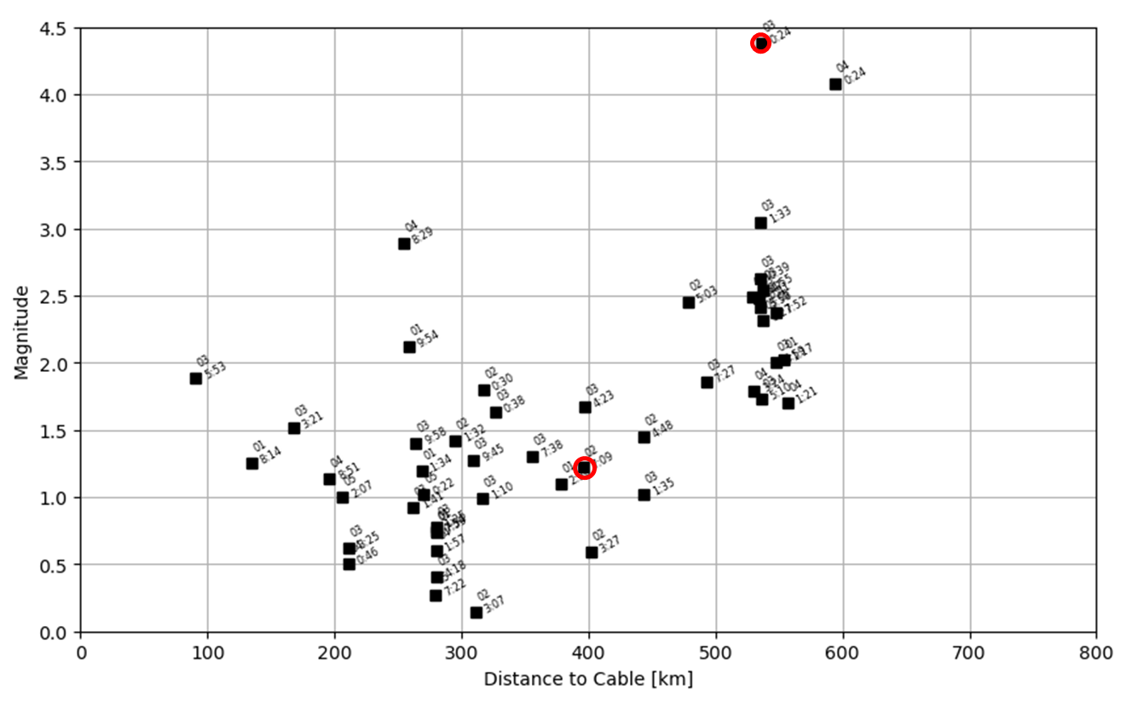

|  |  |
| --- | --- |
| This plot (from the OptaSense acquisition report) shows T-phases from the 4.4 magnitude event on the 3rd November 2021 at 00:24 approximately 540km of the cables. The T-phase (‘Tertiary’ phase) has a higher frequency content compared to the background noise and corresponds to acoustic energy transmitted through the ocean. |  |
| This plot (from the OptaSense acquisition report) shows another T-phase recorded on the North cable in the 12-25 Hz frequency range from the 2nd November 2021 from about 8 in the morning. This is thought to be the 1.2 magnitude event located about 400km from the cables.  Also present is a fin whale call (apex at around channel 20000 |  |

|  |  |
| --- | --- |
| This plot to the right shows a 2.45 magnitude earthquake (nc73647855) located about 500km from the cables. The earthquake occurred on the 2rd November 2021 at 15:03:55 and was detected a minute later on the North cable. The data shown is recorded on the North cable after application of a 2.5Hz high pass filter. |  |

## Vessel Challenge

### Day 1 [1st November 2021]

|  |  |
| --- | --- |
|  |  |
|  | |
| |  |  | | --- | --- | | **MMSI** | **FileName** | | 477852900 | Slx_South_20211101220154_30_2_200.mat | | 477852900 | Slx_South_20211101220209_30_2_200.mat | | 477852900 | Slx_South_20211101220224_30_2_200.mat | | 477852900 | Slx_South_20211101220239_30_2_200.mat | | 477852900 | Slx_South_20211101220254_30_2_200.mat | | 477852900 | Slx_South_20211101220309_30_2_200.mat | | 477852900 | Slx_South_20211101220324_30_2_200.mat | | 477852900 | Slx_South_20211101220339_30_2_200.mat | | 477852900 | Slx_South_20211101220354_30_2_200.mat | | |

### Day 2 [2nd November 2021]

|  |  |
| --- | --- |
|  |  |
|  | |
| |  |  | | --- | --- | | **MMSI** | **FileName** | | 366396000 | Slx_South_20211102004824_30_2_200.mat | | 366396000 | Slx_South_20211102004839_30_2_200.mat | | 366396000 | Slx_South_20211102004854_30_2_200.mat | | 366396000 | Slx_South_20211102004909_30_2_200.mat | | 366396000 | Slx_South_20211102004924_30_2_200.mat | | 366396000 | Slx_South_20211102004939_30_2_200.mat | | 366396000 | Slx_South_20211102004954_30_2_200.mat | | 366396000 | Slx_South_20211102005009_30_2_200.mat | | 369499000 | Slx_South_20211102025954_30_2_200.mat | | 369499000 | Slx_South_20211102030009_30_2_200.mat | | 369499000 | Slx_South_20211102030024_30_2_200.mat | | 369499000 | Slx_South_20211102030039_30_2_200.mat | | 369499000 | Slx_South_20211102030054_30_2_200.mat | | 369499000 | Slx_South_20211102030109_30_2_200.mat | | 369499000 | Slx_South_20211102030124_30_2_200.mat | | 369499000 | Slx_South_20211102030139_30_2_200.mat | | 369499000 | Slx_South_20211102030154_30_2_200.mat | | 367709050 | Slx_South_20211102072839_30_2_200.mat | | 367709050 | Slx_South_20211102072854_30_2_200.mat | | 367709050 | Slx_South_20211102072909_30_2_200.mat | | 367709050 | Slx_South_20211102072924_30_2_200.mat | | 367709050 | Slx_South_20211102072939_30_2_200.mat | | 367709050 | Slx_South_20211102072954_30_2_200.mat | | 367709050 | Slx_South_20211102073009_30_2_200.mat | | 367709050 | Slx_South_20211102073024_30_2_200.mat | | 367709050 | Slx_South_20211102073039_30_2_200.mat | | 538007681 | Slx_South_20211102073424_30_2_200.mat | | 538007681 | Slx_South_20211102073439_30_2_200.mat | | 538007681 | Slx_South_20211102073454_30_2_200.mat | | 538007681 | Slx_South_20211102073509_30_2_200.mat | | 538007681 | Slx_South_20211102073524_30_2_200.mat | | 538007681 | Slx_South_20211102073539_30_2_200.mat | | 538007681 | Slx_South_20211102073554_30_2_200.mat | | 538007681 | Slx_South_20211102073609_30_2_200.mat | | 538007681 | Slx_South_20211102073624_30_2_200.mat | | 367162190 | Slx_South_20211102081039_30_2_200.mat | | 367162190 | Slx_South_20211102081054_30_2_200.mat | | 367162190 | Slx_South_20211102081109_30_2_200.mat | | 367162190 | Slx_South_20211102081124_30_2_200.mat | | 367162190 | Slx_South_20211102081139_30_2_200.mat | | 367162190 | Slx_South_20211102081154_30_2_200.mat | | 367162190 | Slx_South_20211102081209_30_2_200.mat | | 367162190 | Slx_South_20211102081224_30_2_200.mat | | 367162190 | Slx_South_20211102081239_30_2_200.mat | | 338603000 | Slx_South_20211102115824_30_2_200.mat | | 338603000 | Slx_South_20211102115839_30_2_200.mat | | 338603000 | Slx_South_20211102115854_30_2_200.mat | | 338603000 | Slx_South_20211102115909_30_2_200.mat | | 338603000 | Slx_South_20211102115924_30_2_200.mat | | 338603000 | Slx_South_20211102115939_30_2_200.mat | | 338603000 | Slx_South_20211102115954_30_2_200.mat | | 338603000 | Slx_South_20211102120009_30_2_200.mat | | 367171000 | Slx_South_20211102124739_30_2_200.mat | | 367171000 | Slx_South_20211102124754_30_2_200.mat | | 367171000 | Slx_South_20211102124809_30_2_200.mat | | 367171000 | Slx_South_20211102124824_30_2_200.mat | | 367171000 | Slx_South_20211102124839_30_2_200.mat | | 367171000 | Slx_South_20211102124854_30_2_200.mat | | 367171000 | Slx_South_20211102124909_30_2_200.mat | | 367171000 | Slx_South_20211102124924_30_2_200.mat | | 367171000 | Slx_South_20211102124939_30_2_200.mat | | 366425240 | Slx_South_20211102134354_30_2_200.mat | | 366425240 | Slx_South_20211102134409_30_2_200.mat | | 366425240 | Slx_South_20211102134424_30_2_200.mat | | 366425240 | Slx_South_20211102134439_30_2_200.mat | | 366425240 | Slx_South_20211102134454_30_2_200.mat | | 366425240 | Slx_South_20211102134509_30_2_200.mat | | 366425240 | Slx_South_20211102134524_30_2_200.mat | | 366425240 | Slx_South_20211102134539_30_2_200.mat | | 366425240 | Slx_South_20211102134554_30_2_200.mat | | |

### Day 3 [3rd November 2020]

|  |  |
| --- | --- |
|  |  |
| |  |  | | --- | --- | | **MMSI** | **FileName** | | 255613000 | Slx_South_20211103012354_30_2_200.mat | | 255613000 | Slx_South_20211103012409_30_2_200.mat | | 255613000 | Slx_South_20211103012424_30_2_200.mat | | 255613000 | Slx_South_20211103012439_30_2_200.mat | | 255613000 | Slx_South_20211103012454_30_2_200.mat | | 255613000 | Slx_South_20211103012509_30_2_200.mat | | 255613000 | Slx_South_20211103012524_30_2_200.mat | | 255613000 | Slx_South_20211103012539_30_2_200.mat | | 255613000 | Slx_South_20211103012554_30_2_200.mat | | 368206000 | Slx_South_20211103043924_30_2_200.mat | | 368206000 | Slx_South_20211103043939_30_2_200.mat | | 368206000 | Slx_South_20211103043954_30_2_200.mat | | 368206000 | Slx_South_20211103044009_30_2_200.mat | | 368206000 | Slx_South_20211103044024_30_2_200.mat | | 368206000 | Slx_South_20211103044039_30_2_200.mat | | 368206000 | Slx_South_20211103044054_30_2_200.mat | | 368206000 | Slx_South_20211103044109_30_2_200.mat | | 368206000 | Slx_South_20211103044124_30_2_200.mat | | 368293000 | Slx_South_20211103092054_30_2_200.mat | | 368293000 | Slx_South_20211103092109_30_2_200.mat | | 368293000 | Slx_South_20211103092124_30_2_200.mat | | 368293000 | Slx_South_20211103092139_30_2_200.mat | | 368293000 | Slx_South_20211103092154_30_2_200.mat | | 368293000 | Slx_South_20211103092209_30_2_200.mat | | 368293000 | Slx_South_20211103092224_30_2_200.mat | | 368293000 | Slx_South_20211103092239_30_2_200.mat | | 368293000 | Slx_South_20211103092254_30_2_200.mat | | 366738920 | Slx_South_20211103130324_30_2_200.mat | | 366738920 | Slx_South_20211103130339_30_2_200.mat | | 366738920 | Slx_South_20211103130354_30_2_200.mat | | 366738920 | Slx_South_20211103130409_30_2_200.mat | | 366738920 | Slx_South_20211103130424_30_2_200.mat | | 366738920 | Slx_South_20211103130439_30_2_200.mat | | 366738920 | Slx_South_20211103130454_30_2_200.mat | | 366738920 | Slx_South_20211103130509_30_2_200.mat | | 244149000 | Slx_South_20211103233428_10_1_200.mat | | 244149000 | Slx_South_20211103233443_10_1_200.mat | | 244149000 | Slx_South_20211103233458_10_1_200.mat | | 244149000 | Slx_South_20211103233513_10_1_200.mat | | 244149000 | Slx_South_20211103233528_10_1_200.mat | | 244149000 | Slx_South_20211103233543_10_1_200.mat | | 244149000 | Slx_South_20211103233558_10_1_200.mat | | 244149000 | Slx_South_20211103233613_10_1_200.mat | | |

### Day 4 [4th November 2021]

|  |  |
| --- | --- |
|  |  |
|  | |
| |  |  | | --- | --- | | **MMSI** | **FileName** | | 352927000 | Slx_South_20211104020728_10_1_200.mat | | 352927000 | Slx_South_20211104020743_10_1_200.mat | | 352927000 | Slx_South_20211104020758_10_1_200.mat | | 352927000 | Slx_South_20211104020813_10_1_200.mat | | 352927000 | Slx_South_20211104020828_10_1_200.mat | | 352927000 | Slx_South_20211104020843_10_1_200.mat | | 352927000 | Slx_South_20211104020858_10_1_200.mat | | 352927000 | Slx_South_20211104020913_10_1_200.mat | | 368038000 | Slx_South_20211104051643_10_1_200.mat | | 368038000 | Slx_South_20211104051658_10_1_200.mat | | 368038000 | Slx_South_20211104051713_10_1_200.mat | | 368038000 | Slx_South_20211104051728_10_1_200.mat | | 368038000 | Slx_South_20211104051743_10_1_200.mat | | 368038000 | Slx_South_20211104051758_10_1_200.mat | | 368038000 | Slx_South_20211104051813_10_1_200.mat | | 368038000 | Slx_South_20211104051828_10_1_200.mat | | 368038000 | Slx_South_20211104051843_10_1_200.mat | | 357772000 | Slx_South_20211104103358_10_1_200.mat | | 357772000 | Slx_South_20211104103413_10_1_200.mat | | 357772000 | Slx_South_20211104103428_10_1_200.mat | | 357772000 | Slx_South_20211104103443_10_1_200.mat | | 357772000 | Slx_South_20211104103458_10_1_200.mat | | 357772000 | Slx_South_20211104103513_10_1_200.mat | | 357772000 | Slx_South_20211104103528_10_1_200.mat | | 357772000 | Slx_South_20211104103543_10_1_200.mat | | 357772000 | Slx_South_20211104103558_10_1_200.mat | | 308717000 | Slx_South_20211104223903_2_1_1000.mat | | 308717000 | Slx_South_20211104223918_2_1_1000.mat | | 308717000 | Slx_South_20211104223933_2_1_1000.mat | | 308717000 | Slx_South_20211104223948_2_1_1000.mat | | 308717000 | Slx_South_20211104224003_2_1_1000.mat | | 308717000 | Slx_South_20211104224018_2_1_1000.mat | | 308717000 | Slx_South_20211104224033_2_1_1000.mat | | 308717000 | Slx_South_20211104224048_2_1_1000.mat | | 308717000 | Slx_South_20211104224103_2_1_1000.mat | | |

### Day 5 [11 November 2021]

|  |  |
| --- | --- |
|  |  |
|  | |
| |  |  | | --- | --- | | **MMSI** | **FileName** | | 366047000 | Slx_South_20211105004633_2_1_1000.mat | | 366047000 | Slx_South_20211105004648_2_1_1000.mat | | 366047000 | Slx_South_20211105004703_2_1_1000.mat | | 366047000 | Slx_South_20211105004718_2_1_1000.mat | | 366047000 | Slx_South_20211105004733_2_1_1000.mat | | 366047000 | Slx_South_20211105004748_2_1_1000.mat | | 366047000 | Slx_South_20211105004803_2_1_1000.mat | | 366047000 | Slx_South_20211105004818_2_1_1000.mat | | 367133160 | Slx_South_20211105074533_2_1_1000.mat | | 367133160 | Slx_South_20211105074548_2_1_1000.mat | | 367133160 | Slx_South_20211105074603_2_1_1000.mat | | 367133160 | Slx_South_20211105074618_2_1_1000.mat | | 367133160 | Slx_South_20211105074633_2_1_1000.mat | | 367133160 | Slx_South_20211105074648_2_1_1000.mat | | 367133160 | Slx_South_20211105074703_2_1_1000.mat | | 367133160 | Slx_South_20211105074718_2_1_1000.mat | | 354739000 | Slx_South_20211105142254_30_2_200.mat | | 354739000 | Slx_South_20211105142309_30_2_200.mat | | 354739000 | Slx_South_20211105142324_30_2_200.mat | | 354739000 | Slx_South_20211105142339_30_2_200.mat | | 354739000 | Slx_South_20211105142354_30_2_200.mat | | 354739000 | Slx_South_20211105142409_30_2_200.mat | | 354739000 | Slx_South_20211105142424_30_2_200.mat | | 354739000 | Slx_South_20211105142439_30_2_200.mat | | 354739000 | Slx_South_20211105142454_30_2_200.mat | | 538008032 | Slx_South_20211105164009_30_2_200.mat | | 538008032 | Slx_South_20211105164024_30_2_200.mat | | 538008032 | Slx_South_20211105164039_30_2_200.mat | | 538008032 | Slx_South_20211105164054_30_2_200.mat | | 538008032 | Slx_South_20211105164109_30_2_200.mat | | 538008032 | Slx_South_20211105164124_30_2_200.mat | | 538008032 | Slx_South_20211105164139_30_2_200.mat | | 538008032 | Slx_South_20211105164154_30_2_200.mat | | 538008032 | Slx_South_20211105164209_30_2_200.mat | | |

|  |  |  |  |  |  |  |  |
| --- | --- | --- | --- | --- | --- | --- | --- |
| MMSI | Type | Length | Time  Closest Approach | Range  Closest Approach | Channel  Closest Approach | Easting  Closest Approach | Northing  Closest Approach |
| 366959080 | Fishing | 20 | 01/11/2021 15:19 | 0.466564 | 14517 | 394752.7 | 5002834 |
| 477852900 | Cargo | 179 | 01/11/2021 22:02 | 24.83195 | 39790 | 346890.1 | 4999673 |
| 366396000 | Passenger | 45 | 02/11/2021 00:49 | 5.24757 | 20386 | 382936.4 | 5001121 |
| 369499000 | Other | 210 | 02/11/2021 03:01 | 10.04067 | 33182 | 358489.2 | 5004421 |
| 367709050 | Fishing | 37 | 02/11/2021 07:29 | 25.69652 | 23468 | 376709.7 | 5000611 |
| 538007681 | Cargo | 262 | 02/11/2021 07:35 | 5.119048 | 14490 | 394808.3 | 5002835 |
| 367162190 | Fishing | 26 | 02/11/2021 08:11 | 8.415492 | 13451 | 396921.1 | 5002945 |
| 338603000 | Fishing | 24 | 02/11/2021 11:59 | 19.81567 | 5454 | 413170.3 | 5004050 |
| 367171000 | Fishing | 27 | 02/11/2021 12:48 | 1.913953 | 27050 | 369766.5 | 5002571 |
| 366425240 | Fishing | 23 | 02/11/2021 13:44 | 1.428826 | 25539 | 372581.1 | 5001359 |
| 255613000 | Cargo | 180 | 03/11/2021 01:25 | 15.29725 | 24313 | 375007.7 | 5000759 |
| 368206000 | Fishing | 28 | 03/11/2021 04:40 | 7.431036 | 9058 | 405859.4 | 5003362 |
| 368293000 | Fishing | 114 | 03/11/2021 09:21 | 0.833626 | 34591 | 356439.1 | 5002415 |
| 366738920 | Fishing | 21 | 03/11/2021 13:04 | 27.7131 | 9889 | 404167.9 | 5003251 |
| 244149000 | Cargo | 156 | 03/11/2021 23:35 | 44.19599 | 20411 | 382876 | 5001161 |
| 352927000 | Cargo | 200 | 04/11/2021 02:08 | 17.84723 | 28241 | 367697.4 | 5003836 |
| 368038000 | Fishing | 83 | 04/11/2021 05:17 | 0.964288 | 25717 | 372229.6 | 5001446 |
| 357772000 | Cargo | 181 | 04/11/2021 10:35 | 10.07669 | 21443 | 380817.1 | 5000727 |
| 308717000 | Cargo | 224 | 04/11/2021 22:40 | 30.62101 | 21646 | 380415.1 | 5000632 |
| 366047000 | Fishing | 87 | 05/11/2021 00:47 | 5.123894 | 31789 | 361006.6 | 5005697 |
| 367133160 | Towing | 37 | 05/11/2021 07:46 | 14.75654 | 12451 | 398960.5 | 5002976 |
| 354739000 | Cargo | 180 | 05/11/2021 14:24 | 10.24462 | 45517 | 335552.1 | 5001776 |
| 538008032 | Cargo | 190 | 05/11/2021 16:41 | 27.5723 | 22444 | 378795.4 | 5000511 |
| 257842000 | Cargo | 204 | 06/11/2021 01:41 | 43.02252 | 23869 | 375892.8 | 5000646 |
| 259976000 | Cargo | 199 | 06/11/2021 09:11 | 30.798 | 20342 | 383027.9 | 5001112 |